Lab Manual for Application Lab

Subject: SPM&A

TY BTech/IT
Software Engineering
Faculty:
Prof. S.T. Shingade, Ms. Sunita Suralkar

List of Experiments

- Selecting a Project and Define Project Objectives
- Write a Detailed Problem Statement
- Prepare Project Initiation Documents
  - Business Case
  - Project Charter
  - Team Contract
  - Scope Statement
- Prepare Project Planning Documents
  - Estimation Document
  - Risk Management Plan
  - Time Management Plan (Schedule)
  - SQA Plan
  - SCM Plan
  - Test Plan
- Prepare Product Design Documents
  - Data modeling- ER diagram
  - Functional modeling: Data flow diagram
  - Use case diagram
  - Class Diagram
  - Database design
  - Algorithm/psuedocode
  - Test cases
- End Project Document
  - Milestone report
  - Summary of project result
  - Lesson Learned report
  - Client acceptance form
- Project Assessment

Experiment No. 1

Aim: Selecting a Project and Define Project objective

Theory:

Every student will be assigned a software development project. Student has to perform the given assignments for the project assigned.
Finally he has to prepare a Project Report as per the format below for the project assigned.

Project objective:

The project objective describes the project’s outcomes: intended and direct, short- and medium-term effects on the target group. The project objective must lie within the scope of the project, and one must be able to directly attribute the effects to the project. The project objective is often formulated in terms of the project’s utility for the target group: “Better… higher…” It also makes sense to formulate the project objective as a situation to be achieved in the future.

Example:

Name: Sponsorship Management system

Objective:

To develop software for Sponsorship management system, where a sponsorship team can organize and co-ordinate their activities.
A sponsorship team consists of Sponsorship Representatives, Sector Heads and the Chief Sponsorship Officer.

Functionality needs to provide by the software to users are:

- Password-protected user accounts for each user, assigned and authorized by the admin.

- A database that holds data about:
  - All the companies (each in one of several sectors)
  - The human representatives of the company who must be contacted.
  - A log of meetings for co-ordinating the activities of Sponsorship Representatives.
  - Information about which team member gains which company's sponsorship.

- Restricted access: each team member has one of three levels of access: Sponsorship Representatives, Sector Heads and the Chief Sponsorship Officer.
Depending on their level, they have access to different (more or less) data and features.

- Reports can be generated on a real-time basis.

- The database can be sorted and searched.

- Members receive notifications on the activities of other members on their homepage.

Conclusion: A Software development Project is selected and Project objective is defined .The project objectives gives detail about the functionality of software provides to funding teams.

Experiment No. 2

Aim: To write a Detailed Problem statement.

Theory:
A problem statement defines a description of issues and problems that require dealing with by some form of team specializing in the solving of problems and other issues. Generally, the problem statement is what is handed over to the team before they get to work on solving the problem. Such statements usually cover such aspects as the following:
Define the problem itself and suggest reasons as to why a team is required?
It usually denotes the person who decides when the team has suggested a fair and useful tactic for solving the issue.
It usually suggests what form such a solution for the problem should be in. With this it also sets limitations on the project, and may also suggest the form itself, such as a software device, a written action plan, etc.

Example:

Problem Statement

The online sponsorship management system is a software application for large funding teams who must work in parallel and co-ordinate their actions for maximum efficiency. These system provide a collective database of potential and current sponsors (usually large companies like Amul or Times of India) along with contact information of the company representatives. The companies are organized by their respective sectors and one team is assigned to each sector.

Salient features:
- A hierarchy of access, modelled on the existing Sponsorship team
structure:

  - Top-level: Chief Sponsorship Officer (admin)
Who manages the entire system and solely has the ability to add, modify and re-assign team members.
  - Mid-level: Sector Head(s)
Who manage the working of the team. Sponsorship Representatives report their earnings to Sector Heads. A large sector (with a lot of companies) may have a lot of heads.
  - Entry-Level: Sponsorship Representatives
. These are the foot soldiers of the sponsorship team, making cold calls, sending emails, and meeting with the company representatives. A sponsorship representative may be dealing with more than one company at once, but in general each company may be dealing with only one sponsorship representative.
- A common database which facilitates efficient collaborative effort between members of the
Sponsorship teams. This database stores:
  - Updates on the real-time status of the sponsor companies.
  - Name, contact information of the key personnel in the sponsoring companies.
  - A log of meetings held with sponsorship team members and potential sponsors, organized by sector.

- A reporting feature of the amount of sponsorship received on a real-
time basis:

  - A reporting of the total amount received.
  - A sector-wise total reporting of the Sponsorship amounts.
  - A company-wise breakup of Sponsorship amounts.
  - A reporting feature of the amount of sponsorship brought by each
individual SponsRep or SectorHead.

Corresponding reports can only be viewed by users with the
appropriate authorization level.
The systems vary in size. The size of the system is usually proportionate to the size of the sponsorship team. This is because the number of companies, sectors, and sponsorship team members and therefore records in the system, will be higher in a larger organization.

Conclusion: Detailed Statement of Problem (DSP) has been decided

Experiment No 3

Aim: To Prepare Project initiation Document
- Business Case
- Project charter
- Team contract
- Scope statement

Theory:
a) Business Case: A business case captures the reasoning for initiating a project or task. It is often presented in a well-structured written document, but may also sometimes come in the form of a short verbal argument or presentation. The logic of the business case is that, whenever resources such as money or effort are consumed, they should be in support of a specific business need.

b) Project charter: It provides a preliminary delineation of roles and responsibilities, outlines the project objectives, identifies the main stakeholders, and defines the authority of the project manager. It serves as a reference of authority for the future of the project.

c) Team contract: Team Contract is a document prepared by each team prior to starting work on group projects.

d) Scope statement: The scope statement details the project deliverables and describes the major objectives. The objectives should include measurable success criteria for the project.

Online Sponsorship Management System
- Business Case
Introduction

The main goal of this project is to deliver an application that facilitates the organization and co-operation of large sponsorship departments. This is done by providing a centralized database which can be accessed by multiple team members simultaneously.
________________________________________________________________________
Business Objective

The sponsorship department is responsible for contacting potential companies who may be interested in sponsoring certain events (either on behalf of the company itself or on the behalf of another client). The application aids the department’s strategic goals as it allows the focus of the department’s activities to shift away from bookkeeping activities and towards gaining more contracts. This has the potential of significantly increasing the amount of money earned by the department in two ways: decreasing the time needed to plan and focus the activities, and by creating a database of past companies who may be interested in sponsoring events in the future.
The application is designed to be used in-house, but may also be licensable to other companies, bringing in additional revenue.

________________________________________________________________________
Current Situation and Problem/Opportunity Statement
To conduct any large scale event successfully we require large amounts of funding. To generate the necessary funds, each event has a Sponsorship Department, which contacts companies who may be interested in advertising at the event (the sponsorship department may be exclusive to the events or it may be a separate entity that contracts for several events).
The Sponsorship Department is split into multiple teams, one for each sector of companies which it elicits funds from. Each team comprises of “Sponsorship Representatives” who are the basic unit of the team; they perform the main functions associated with gaining sponsors, including contacting representatives of the various companies and finding new possible sponsors. “Sector heads” hold a managerial position over one or more teams, and monitor their progress. A “Chief Sponsorship Officer” manages all the above and collects.

To begin with, a master list of all companies and their contact details is compiled. Contact details include company name, company representative name/s, phone numbers (both company office and rep’s mobile numbers), email ids, etc. These details might change over time, hence changing the records in everyone's copies are cumbersome.
The 'sponsorship representatives' then call each company and schedule meetings with them in hopes of getting them to sponsor the festival. There is a lot of redundancy in this process as two 'sponsorship representatives' might be contacting the same company without having knowledge that their colleagues are also doing the same. Hence, this leads to parallel talks with the company, which is a waste of time for both the company and the festival. The 'sector heads' have to take meetings to monitor the progress of their team. The 'Chief Sponsorship Officer' in turn has to do the same with 'sector heads'. The 'Chief Sponsorship Officer' also has to manually keep a track of the money and companies that are getting associated with the festival.
The aim of this project is to streamline this process making work more efficient for entire sponsorship department.

________________________________________________________________________
Critical Assumption and Constraints
- Current consultant and client must actively support the project and must pay for itself within one year.
- The project manager must lead the effort, and the project team must include participants from several parts of company as well as client side.
- New software must run on existing hardware and software.
- It must be easily accessible by the client via an online portal.

________________________________________________________________________
Analysis of Options and Recommendation

There three options to address this opportunity:
- Do nothing as the department is working well without the application.
- Outsource the development of part of this project to another company as we are primarily a financing firm.
- Design and implement new project with the existing hardware and software

________________________________________________________________________
Preliminary Projects Recruitments
A centralized database which allows multiple users to access and update it simultaneously.
Restricted access to the database via various user levels.
A reporting and analytics feature that allows the users (at each level) to access statistics relevant to him or her.

Functionality needs to provide by the software to Sponsorship Representatives are:
- Registration
- Login
- View, Edit, Add Companies
- View, Edit, Add Company Executives
- Modify The Meeting Log
- Overview Of Progress
- Generating Reports Of The Various Statistics.
Functionality needs to provide by the software to Sector Heads are:
Apart from the functionality of the sponsorship representatives, the sector head has the following additional functions:
- Assigning Sponsorship Representative
- Viewing Sector Statistics
- Editing Account Log

Functionality needs to provide by the software to Chief Sponsorship Officer are:
Apart from the functionality of the sponsorship representatives and the sector head, the chief sponsorship officer has the following additional functions:
- Adding And Removing Sponsorship Representatives
- Assigning And Removing Sector Heads
- Viewing Statistics For All Data (I.E. Global Access To Data)
________________________________________________________________________
Budget Estimate and Financial Analysis
Preliminary budget estimate of the project is Rs. 10,00,000. The estimate is based on Labour Estimate they will work for 2-4 months. The expected number of team members is 3. Their monthly salary is Rs.80,000. Contract labour will work for 16 hrs at Rs. 2000 /hr. Hardware utilization cost is approximately Rs.1,60,000. Software cost is approximately Rs.0 as open-source resources are being used. Final testing will take Rs. 60,000.
Exhibit summarizes the projected cost and benefits and shows the estimated Net Present Value (NPV). All the financial estimates are very encouraging. The estimated payback is in one year as estimated by the sponsor. The NPV is .
________________________________________________________________________
Schedule Estimate

The sponsor would like to see the project completed in 2-4 months , but there is some flexibility in schedule. We will assume that new system will have life at least for 5-6 years. Updates are to be made infrequently.
________________________________________________________________________

Potential Risk

There are several risk in a project of this scope. Database Security, Concurrent Access, Online Hacking, Tools Unavailability, Connection failure, System failure, User authentication, Project Delayed, No market response, Master file corrupted are all issues which must be dealt with.
However, the main business risk is the monetary risks involved not realizing the project benefits. If the team members do not use the software, then the project shall not receive the expected returns. User interactions should thus be simplified and optimized.

________________________________________________________________________

Exhibits

Discount rate | 10%
Assume the project is done in 6 months
 | Year 0 | Year 1 | Year 2 | Year 3 | Year 4 | Total
Costs | 5,00,000 | 1,25,000 | 1,25,000 | 1,25,000 | 1,25,000 | 10,00,000
Discount Factor | 1 | 0.91 | 0.83 | 0.75 | 0.68
Discounted Costs | 5,00,000 | 1,13,750 | 1,03,750 | 93,750 | 85,000 | 8,96,250
Benefits | 0 | 4,00,000 | 4,00,000 | 4,00,000 | 4,00,000 | 16,00,000
Discount Factor | 1 | 0.91 | 0.83 | 0.75 | 0.68
Discounted Benefits | 0 | 3,64,000 | 3,32,000 | 3,00,000 | 2,72,000 | 12,68,000
 |  |  |  |  |  | 3,71,750
Discounted benefits – costs | -5,00,000 | 2,50,250 | 2,28,250 | 2,06,250 | 1,87,000
Cumulative discounted benefits – costs | -5,00,000 | -2,49,750 | -21,500 | 1,84,750 | 3,71,750
NPV = Rs. 3,71,750
ROI = (3,71,750 / 8,96,250)*100 = 41.48 %

- Project charter
_______________________________________________________________________
Project Title: Online Sponsorship Management System project
________________________________________________________________________
Project Start Date: 4 January 2016
________________________________________________________________________
Project End Date: 24 April 2016
________________________________________________________________________
Project Manager: Abhishek Divekar, 9819712190, abhishek.r.divekar@gmail.com
________________________________________________________________________
Project Budget Information: This firm has allocated Rs. 4,00,000 for this project. The majority of costs for this project will be internal labour.
________________________________________________________________________
Project Objectives: Develop a new web-based application for a Sponsorship Management System. This will include all the functionality required for the sponsorship department of any event to operate efficiently. Salient features include a database storing historical sponsorship data, three authorization levels, and sharing of relevant data among member of the team to keep the sponsorship department organized.
________________________________________________________________________
Approach:
- Develop survey to determine critical features of the new website and input from the project sponsor (professor).
- Review internal external templates and examples of project management documents.
- Develop the intranet site using an interactive approach, soliciting a great deal of user feedback.
- Determine a to measure the value of the intranet site in terms of reduced costs and revenues, both during the project and one year after project completion.
________________________________________________________________________

Roles and Responsibilities:
Name | Role | Responsibility
Manish Joshi | SPM Professor at V.J.T.I. | Project Sponsor, monitor project
Abhishek Divekar | Project Manager | Plan and execute project, project design and code construction activities.
Advik Shetty | Team Member | Project design and code construction activities.
Janit Mehta | Team Member | Project design and code construction activities.

- Team Contract
Code of Conduct: As a project team, we will:
- Work proactively, anticipating potential problems and working to prevent them.
- Keep other team member informed of information related to the project.
- Focus on what is best for the entire project team.
___________________________________________________________
Participation: we will:
- Be honest and open during all project activities.
- Encourage diversity in team work.
- Provide opportunity for equal participation.
- Be open to new approaches and consider new ideas.
- Have one discussion at a time.
__________________________________________________________

Communication: We will:
- Decide as a team on the best way to communicate.
- Have the project manager facilitate all meeting and arrange for phone as needed.
- Present ideas clearly and concisely.
- Keep discussion on track.
___________________________________________________________

Problem Solving:
- Encourage everyone to participate in solving problems.
- Only use construction criticism and focus on solving problem, not blaming people.
- Strive to build on each other’s ideas.

Meeting Guidelines:
- Meet more frequently every meeting.
- Hold other meetings as needed.

Roles and Responsibilities
Company has done the allotment for “Online Sponsorship Management System” as follow.

Name | Role | Position | Contact
Abhishek Divekar | Project manager | Project Manager | abhishek.r..divekar@gmail.com
Advik Shetty | Team Member | Developer | advik_shetty@hotmail.com
Janit Mehta | Team Member | Developer | janithmehta@gmail.com

- Scope statement
_____________________________________________________________
Project Title : Online Sponsorship Management System

Date : 1st Jan, 2016

Prepared By : Abhishek Divekar, +919819712190 abhishek.r.divekar@gmail.com
________________________________________________________________________
Project Justification:
The Sponsorship Management System is a software that is meant to aid large funding departments to organize and coordinate their activities. Structurally departments are split into teams, where each team tackles a certain sector of companies from which they elicit funds (e.g. "Steel", "FMCG", "Automobiles", etc. are all sectors). At present most teams co-ordinate their work in an offline manner, through paper or possibly email, leading to disorganization and redundancy. This problem is exacerbated in the case of discretely located teams. Another significant issue is the intermingling of companies visited by different teams and members of the same team; for large teams, this becomes a problem.

A better model would include centralized location where all the teams' data is organized. Access to data and functionality could be restricted. Team activities may be co-ordinated and monitored, thus preventing redundancy and greatly reducing the overhead of monitoring.
________________________________________________________________________
Product Characteristics and requirements
Major software functions
Sponsorship Representative functionality:

- REGISTRATION:

Since access is restricted to only members of the team, adding new team members (called "Sponsorship Representatives") is an involved process. The administrator (called the "Chief Sponsorship Officer") must be contacted to add a new person to the database. Then, the team leaders (called "Sector Heads") must add the individual to their team.

- LOGIN:
Following registration, a Sponsorship Representative (abbreviated to "SponsRep") can login using his or her ID. From there, the SponsRep is redirected to their Home page.

3. VIEW, EDIT, ADD COMPANIES :
A SponsRep is allowed to access, insert, update and delete information of potential sponsoring companies from his sector only. As we progress with the sponsorship process, the status of a company is often updated, and tells us if the company is interested or not (the default is “not contacted”).

4. VIEW, EDIT, ADD COMPANY EXECUTIVES:
A SponsRep is allowed to access, insert, update and delete information of potential sponsoring companies from his sector only.

5. MODIFY THE MEETING LOG:
A SponsRep logs meetings made with various company executives of various companies in his sector, into a common meeting log which is shared by all SponsReps in the sector.
The purpose of this meeting log is to prevent unnecessary contacting of companies. SponsReps should log their meetings with a particular, and thus inform the other SponsReps that they are going to meet/call their company in the future. After a meeting is completed, the SponsRep should update the outcome of the meeting, for later reference for himself and fellow SponsReps. At this point the company status also may need to be updated.

6. ADD MONEY TO THE FESTIVAL ACCOUNT:
If a SponsRep had managed to acquire a sponsorship grant from a company, then he/she must log it into the AccountLog. However, for purposes of security, the SponsRep only has access to his own entries in the AccountLog. Festival entries also cannot be deleted by SponsReps; they can only be deleted by their respective Sector Heads.

7. OVERVIEW OF PROGRESS:
The SponsRep can see the overview of the progress he/she has made so far. The overview includes Sector, Meetings held, Companies signed, calls made, emails sent and amount earned.

Sector Head functionality
Apart from the functionality of the sponsorship representatives, the sector head has the following additional functions:
1. ASSIGNING SPONSORSHIP REPRESENTATIVE
Sector heads can assign a sponsorship representative to his/her sector.
2. VIEWING SECTOR STATISTICS
Sector heads can view statistics about his sector like number of companies that have sponsored the event, the amount the sector has earned, the highest earner etc.
3. EDITING ACCOUNT LOG
If a Sector Head had managed to acquire a sponsorship grant from a company, then he/she must log it into the AccountLog. However, for purposes of security, the SponsRep only has access to his own entries in the AccountLog. Festival entries also cannot be deleted by SponsReps, they can only be deleted by their respective Sector Heads.

Chief Sponsorship Officer
Apart from the functionality of the sponsorship representatives and the sector head, the chief sponsorship officer has the following additional functions:
- ADDING AND REMOVING SPONSORSHIP REPRESENTATIVES
The Chief Sponsorship Officer can add, remove and edit sponsorship representatives from the system.
- ASSIGNING AND REMOVING SECTOR HEADS
The Chief Sponsorship Officer can assign a Sponsorship Head to a sector. He can assign 1 or more sector heads to a sector.
- VIEWING EVENT STATISTICS
The Chief Sponsorship Officer can view statistics about all the sectors like number of companies that have sponsored the event, the amount the sector has earned, the highest earning sector etc.
___________________________________________________________________________

Summary of product deliverables:
1.Articles
2.Links
3.Expert database
4.User requested features.
5.nternet site design
6.Test plan
7.Project benefit measurement plan
__________________________________________________________________________

Conclusion:
The Online Sponsorship Management System case study demonstrates how one organization managed an information technology project from its initiation through its closure. The case study provides several samples of outputs produced for initiating (including pre-initiating), planning, executing, monitoring and controlling, and closing as: Business case, project charter, scope statement, and team contract.

Experiment No. 4

Aim: To prepare Project Planning Documents
- Estimation document.
- Risk Management plan
- Time Management Plan
- SQA plan
- SCM plan
- Test plan

Theory:
a) Estimation document: Estimation document includes estimation of cost, time and person.

b) Project risk management is the art and science of identifying, analyzing, and responding risks throughout the life of a project and in the best interests of meeting project objectives.

c) Time management is the act or process of planning and exercising conscious control over the amount of time spent on specific activities, especially to increase effectiveness, efficiency or productivity
d) SQA: Software quality assurance (SQA) consists of a means of monitoring the software engineering processes and methods used to ensure quality. The SQA plan provides a road map for instituting software quality assurance.
e) SCM: Supply chain management (SCM) is the management of the flow of goods. It includes the movement and storage of raw materials, work-in-process inventory, and finished goods from point of origin to point of consumption.
f) Test plan:
A test plan documents the strategy that will be used to verify and ensure that a product or system meets its design specifications and other requirements. A test plan is usually prepared by or with significant input from test engineers.

Sponsorship Management system

- Estimation document
Estimation technique LOC
(Lines of code)
What's a line of code? -Total no of lines in a project. Many different ways to count lines (e.g., with or without comments, counting statements rather than lines, or counting lines in a automatically formatted code)
Estimate table for LOC method
FUNCTION | Optimistic | Most Likely | Pessimistic | Estimate LOC
User interface and control | 500 | 800 | 1300 | 833
Populate the database | 400 | 650 | 1000 | 666
Database setup | 200 | 350 | 500 | 366
Styling | 150 | 300 | 500 | 308
User Homepages Data | 50 | 90 | 150 | 93
Query input | 600 | 1100 | 1300 | 1050
Display Query results | 800 | 1200 | 1800 | 1233
Result sorting and searching | 100 | 200 | 300 | 200
Statistics | 150 | 300 | 500 | 308
Estimated lines of code |  |  |  | 5057
Estimated LOC = (optimistic + 4* Most Likely + pessimistic)/6
A historical data indicates that organizational average productivity for system of this kind is 800 LOC/pm. labor rate ₹8000 per month based on this cost per line of code ₹10.
Months = 2000/800=2.5 months
Estimation technique FP base (function point base estimation)
Adjusting Function Points
Answer the following questions using a scale of [0-5]: 0 - not important; 5 - absolutely essential. We call them influence factors (Fi).
1. Does the system require reliable backup and recovery? 2
2. Are data communications required? 4
3. Are there distributed processing functions? 5
4. Is performance critical? 2
5. Will the system run in an existing, heavily utilized operational environment? 4
6. Does the system require on-line data entry? 5
7. Does the on-line data entry require the input transaction to be built over multiple screens or operations (user efficiency)? 1
8. Are the master files updated on-line? 4
9. Are the inputs, outputs, files, or inquiries complex? 2
10. Is the internal processing complex? 2
11. Is the code designed to be reusable? 3
12. Is installation included in the design? 1
13. Is the system designed for multiple installations? 4
14. Is the application designed to facilitate change and ease of use by the user? 3
ΣFi = 42
Use an empirical relationship
FP = count total × [0.65 + 0.01 ×(ΣFi)]

Sponsorship Management System FP base Calculations
# of user inputs: (8) *simple (3) = 24
# of user outputs: (7) *simple (4) = 28
# of user inquiries: (6) *simple (3) = 18
#of files: (9) *simple (7) = 63
# of external interfaces: (1) * simple (5) = 5
= 138
- Total of FPs= 138
- FP = count total × [0.65 + 0.01 ×(Σfi)]
= 138 x [0.65 + 0.01 x (42)] = 138 x 1.07 = 147.66
Systems of this type is 13.8 FP/PM. Labour rate is ₹37,245 per person month, cost per FP is approximately ₹2700
Estimated effort is 10.7 person months. For a team of 3, that is 3.57 months per person.
Total Cost = ₹3,98,520
KLOC Calculation
LOC to FP of HTML is 34
KLOC=FP*67=147.66*34=5020.44
Estimation technique Empirical estimation COCOMO model (COnstructive COst MOdel)
COCOMO - Basic Mode
The Basic Model provides the following algorithms:
E=a*(KLOC)^{b}
D = c* (E)^{d}
where E is effort in person-months,
D is duration in months and
a,b,c and d have the following values depending on the type of project.
 | A | b | C | d
Organic | 2.4 | 1.05 | 2.5 | 0.38
Semi  detached | 3.0 | 1.12 | 2.5 | 0.35
Embedded | 3.6 | 1.20 | 2.5 | 0.32
Organic mode: PM = 2.4 * (KDSI)^{1.05}=2.4 * (5.02)^{1.05}=13.06 person months
TDEV = 2.5 (PM) ^{0.38}=2.5* 13.06^{0.38}=6.6374
N = PM / TDEV=13.06/6.6374 = 1.967 ~= 2

Semi-detached mode: PM = 3 * (KDSI) ^{1.12} = 3 * (5.02) ^{1.12} = 18.277 person months
TDEV = 2.5*(PM) ^{0.35} = 2.5*(18.277) ^{0.35} = 6.912
N = PM / TDEV = 18.277 /6.912 = 2.644 ~= 3

Embedded mode: PM = 3.6 * (KDSI) ^{1.2} = 3.6 * (5.02) ^{1.2} = 24.954 person months
TDEV = 2.5 * (PM) ^{0.32} = 2.5 * (24.954) ^{0.32} = 6.998
N = PM / TDEV = 24.954/6.998 = 3.566 ~= 4
KDSI = Kilo Delivered Source Instructions
The size of the Sponsorship product has been estimated to be 5,020 lines of source code. Calculate the effort and the development time required. Considering that this is simple project

Development Effort Multipliers
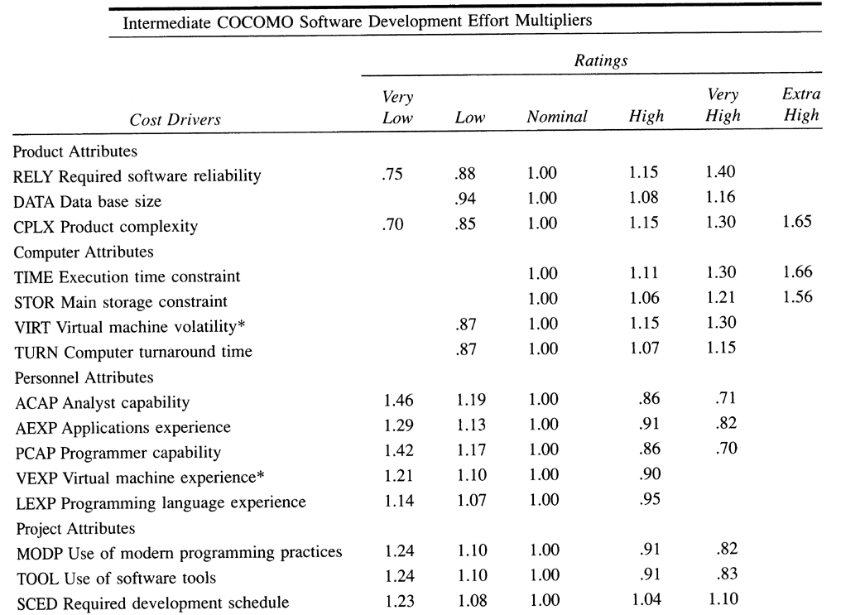

Estimated Task network
Project tasks and their dependencies are noted in this diagrammatic form.
Estimated Timeline chart
A project timeline chart is presented. This may include a time line for the entire project or for each staff member.

Estimated Budget
1.Labour Estimate | Actual time – 10.7 Months
 | Cost/labour month - ₹ 37,245
 | Total Cost - ₹ 3,98,520
2.Contractor labour | Hours worked - 16hrs
 | Cost /labour hr. - ₹200
 | Total - ₹3,200
3.Hardware devices(server) | Unit/hrs. - ₹4000
 | Units - 4
 | Total - ₹16,000
4.Software | Licensed software - ₹ 10,000
5.Testing (h/w and s/w) | ₹ 6000
Total cost | ₹4,33,720

Actual Required Budget
1.Labour Estimate | Actual time - 3 Months x 3 persons
 | Cost/labour month - ₹ 37,245
 | Total Cost - ₹ 3,98,520
2.Hardware devices(server) | Unit/hrs. - ₹4000
 | Units - 4
 | ₹16,000
3.Software | Licensed software - ₹ 5,000
4.Testing (h/w and s/w) | ₹ 6000
Total cost | ₹4, 25, 520

- Risk Management Plan

List Of Risk:
Risk Table
Risk Id | Risks | Risk type | Probability | Impact
1 | Database Security | Technical | 60% | 3
2 | Concurrent Access | Technical | 80% | 3
3 | Online Hacking | Technical | 50% | 3
4 | Tools Unavailability | Market | 40% | 3
5 | Connection failure | Technical | 55% | 1
6 | System failure | Technical | 70% | 3
7 | User authentication | Technical | 30% | 2
8 | Project Delayed | Project | 40% | 3
9 | No market response | Market | 40% | 2
10 | Master file corrupted | Technical | 30% | 3

Overview of Risk Mitigation, Monitoring, Management
An overview of RM3 is provided here. The Complete RM3 is provided as a separate document or as a set of Risk Information Sheets.
Risk ID: 1 (database security) Prob:60% Impact: Critical
Description: Database contains personal information about users. This includes their address, numbers etc. Database also contains information about various products we sell like prices and inventory information.

Refinement/Context:
1: Possibility of hacker attack
2: Unauthorized Staff members getting access to database
Mitigation/Monitoring:
1: Provide database access to authorized personnel only by means of passwords
2: Database backup
Management/Contingency plan/trigger:
1: Use backup database in place of original one.

Risk ID: 2 (concurrent access) prob:80% Impact: Critical
Description: There is a chance that a large number of people are using the system simultaneously and the servers are not able to handle the load
Refinement/Context:
1: Generally, customers access during the day time in the
Normal office hours.
2: During public holidays all people will try to access the
system Which may cause this problem?
Mitigation/Monitoring:
1: Proper resource utilization tools must be used.
2: Response time should be measured periodically.
Contingency plan:
1: Extra backup servers must be kept aside.
2: Server farm must be created.

Risk ID: 3 (Online Hacking) prob:50% Impact: Critical
Description: There is a chance that the hackers might try to deface the website.
Refinement/Context:
1: Hackers might try to deface the website just for fun or to spread
their propaganda.
Mitigation/Monitoring:
1: Try to keep the website as simple as possible.
2: Install packet filters, Intrusion Detection System and Firewall.
Management/Contingency plan/trigger:
To go offline for a short duration
Risk ID: 4 (tools unavailability) prob:40% Impact: Critical
Description: There is a chance that the budget exceeds the limit provided by
Customer due to lack of equipment .
Refinement/Context:
1:There was a sudden rise in the market price of the tools needed
to develop the system
2:The customer demands some additional application to be
included in the system.
Mitigation/Monitoring:
1: Proper study of the market price of tools
2: Effective communication with the customer to know his
demands

Contingency plan:
Intermediate bargain with the customer to explain him about your
additional expenditure.
To add the new applications if customer ready to pay the exceeded
price
Risk ID: 5 (connection failure) Prob:55% Impact: Negligible
Description: During the transaction there may be a chance that the connection of
the user with the system is lost.
Refinement/Context:
1:Possibility of system crash at user end
2:Router damage due to external factors.
Mitigation/Monitoring:
1:Rollback transaction.

Contingency plan:
1:Create a log of failed transaction.

Risk ID: 6 (system failure ) prob:70% Impact: Critical
Description: There is a chance that the system may fail due to some crashes or
Your server may get crash due to no of concurrent accsess .
Refinement/Context:
1:Make use of RAID so that recovery will not be a trouble for you
2:Implement the strong concurrency control mechanism at server
Mitigation/Monitoring:
1: Proper study of the recovery of tools.
2: Proper study of concurrency control.
3: Effective implementation of this.

Contingency plan:
Intermediate contact with the customer to explain him about your
additional expenditure.
To add the new applications if customer ready to pay the exceeded
price
Risk ID: 8 (project delay) prob:40% Impact: Critical
Description: There is a chance that the project may exceed the deadline given for
completion due to lack of recourses such as man power .
Refinement/Context:
1: Try to involve more people in the project.
2: try to conduct progress meeting at lest after 3-4 days.
3: try to implement wok through technique in your company
Mitigation/Monitoring:
1: Proper study of the problem statement
2: Effective planning

Contingency plan:
Intermediate contact to with the customer to explain him about your
additional expenditure.
To add the new applications if customer ready to pay the exceeded
price

- Time Management Plan
WBS and WBS dictionary
- Split project into tasks and estimate time and resources required to complete each task.
- Organize tasks concurrently to make optimal use of workforce.
- Minimize task dependencies to avoid delays caused by one task waiting for another to complete.
- Dependent on project manager’s intuition and experience.
This section presents an overview of project tasks and the output of a project scheduling tool.
Project task set
The process model, framework activities and task set that have been selected for the project are presented in this section.
Defining a Task Set for the Software Project
- There is no single set of tasks that is appropriate for all projects.
- An effective software process should define a collection of task sets, each designed to meet the needs of different types of projects.
- A task set is a collection of software engineering work tasks, milestones, and deliverables.
- Tasks sets are designed to accommodate different types of projects and different degrees of rigor.
- Typical project types:
- Concept Development Projects
- New Application Development Projects
- Application Enhancement Projects
- Application Maintenance Projects
- Reengineering Projects
Obtaining Information
Degree of Rigor:
- Casual
- Structured
- Strict
- Quick Reaction
Defining Adaptation Criteria:
-- This is used to determine the recommended degree of rigor.
Eleven criteria are defined for software projects:
- Size of the project
- Number of potential users
- Mission criticality
- Application longevity
- Stability of Requirements
- Ease of customer/developer communication
- Maturity of applicable technology
- Performance constraints
- Embedded/non-embedded characteristics
- Project staffing
- Reengineering factors

Sponsorship Management System
Adaptation Criteria | Grade | Weight | Entry Point Multiplier |  |  |  |  | Product
Adaptation Criteria | Grade | Weight | Conc | NDev | Enhanc | Maint. | Reeng | Product
Size of the project | 2 | 1.20 | 0 | 1 | 0 | 0 | 0 | 2.4
Number of potential users | 3 | 1.10 | 0 | 1 | 0 | 0 | 0 | 3.3
Mission criticality | 4 | 1.10 | 0 | 1 | 0 | 0 | 0 | 4.4
Application longevity | 3 | 0.90 | 0 | 1 | 0 | 0 | 0 | 2.7
Stability of Requirements | 2 | 1.20 | 0 | 1 | 0 | 0 | 0 | 2.4
Ease of customer/developer communication | 2 | 0.90 | 0 | 1 | 0 | 0 | 0 | 1.8
Maturity of applicable technology | 2 | 0.90 | 0 | 1 | 0 | 0 | 0 | 1.8
Performance constraints | 3 | 0.80 | 0 | 1 | 0 | 0 | 0 | 2.4
Embedded/non-embedded characteristics | 3 | 1.20 | 0 | 1 | 0 | 0 | 0 | 3.6
Project staffing | 2 | 1.00 | 0 | 1 | 0 | 0 | 0 | 2.0
Interoperability | 4 | 1.10 | 0 | 1 | 0 | 0 | 0 | 4.4
Reengineering factors | 0 | 1.20 | 0 | 0 | 0 | 0 | 1 | 0.0
Task set selector 2.8
Task Set Selector value | Degree of Rigor
TSS < 1.2 | Causal
1.0 < TSS < 3.0 | Structured
TSS > 2.4 | Strict

Work break down structure of Sponsorship Management project
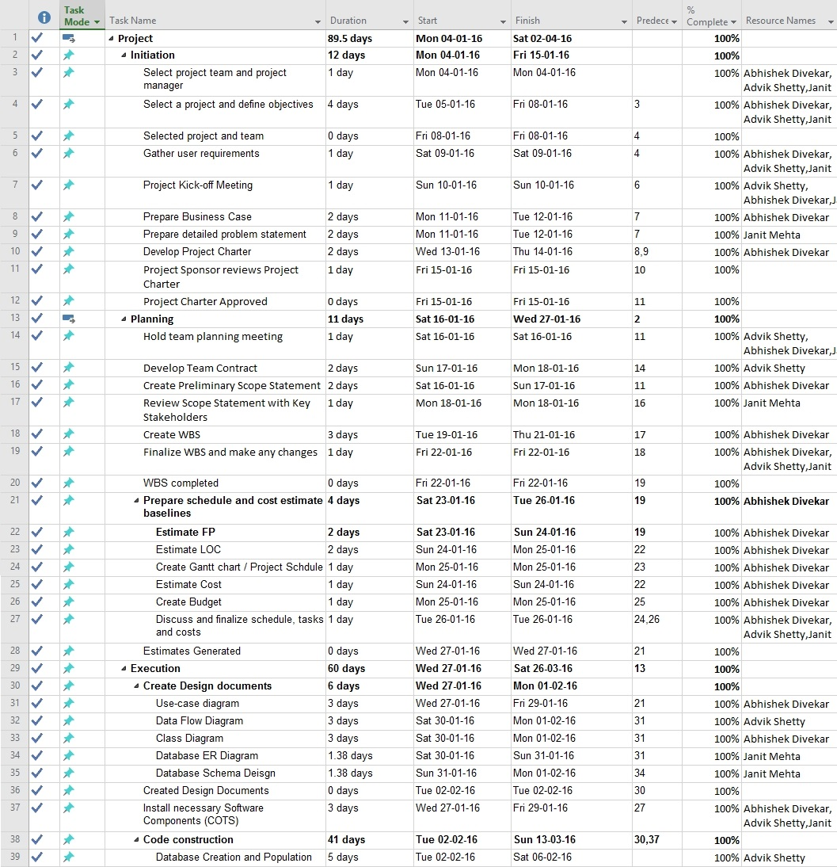

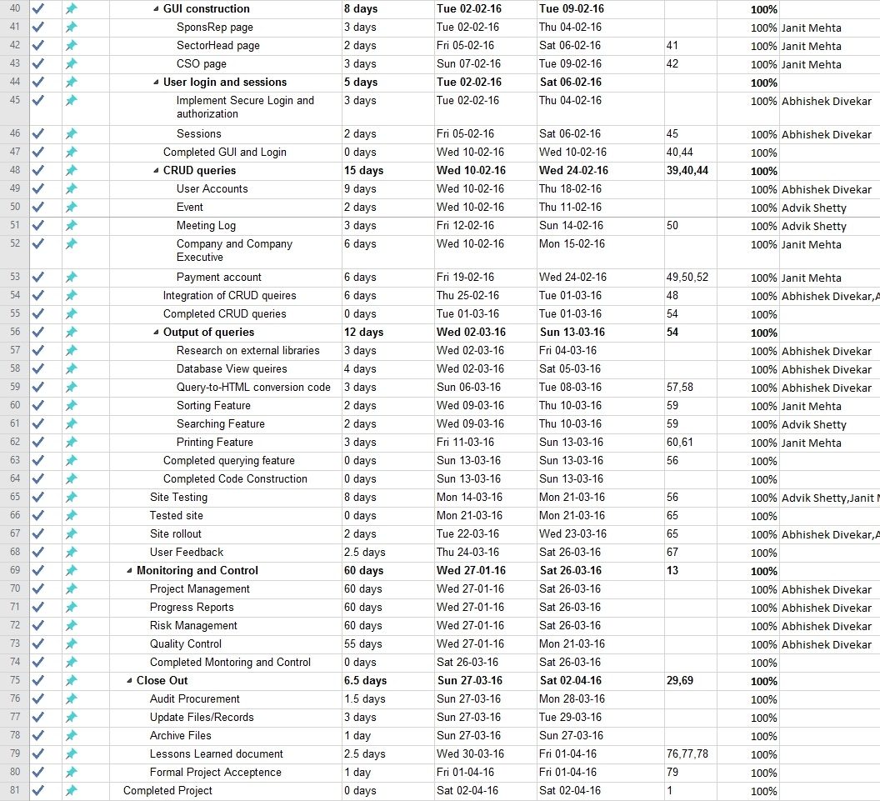
Gantt chart
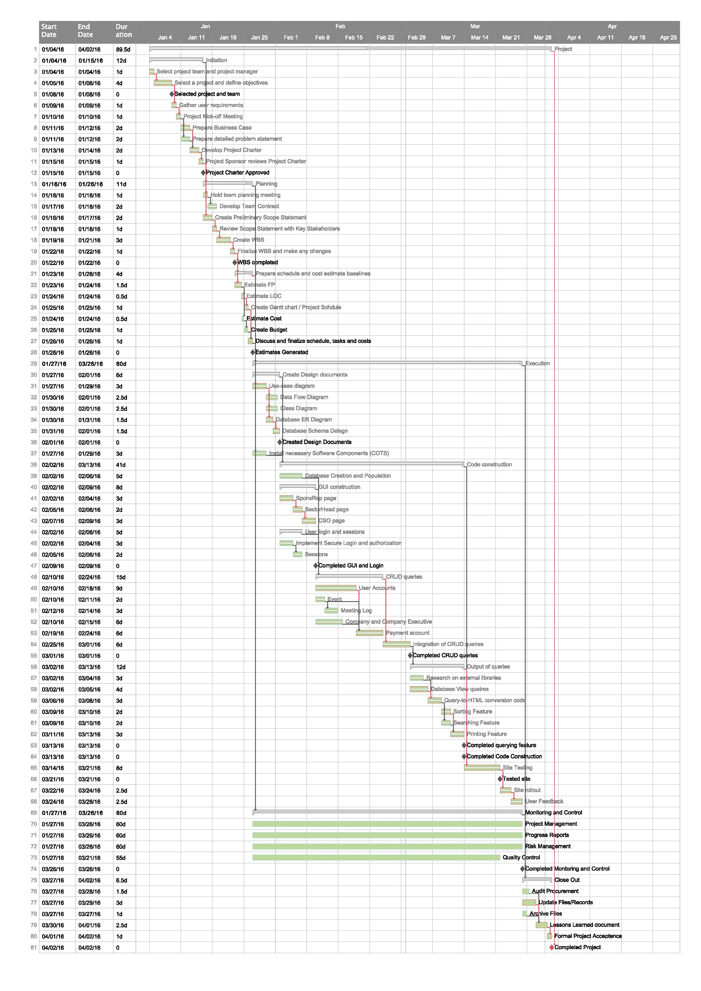
- Software Quality Assurance (SQA) plan
An overview of SQA activities is provided. Note that an SQA Plan is developed for a moderate to large project and may be a separate document or included as an appendix.
The quality control process for this project will consist of the following:
SRS Review: The SRS will be reviewed by a project team.
Design Review: Design document will be reviewed by the project team.
Unit Testing: Programmer is responsible for Unit testing each module.
System Testing: Will be done according to the system test plan, which will be
Reviewed.
Quality Concepts
- Software quality assurance is an umbrella activity that is applied throughout the software process.
- SQA encompasses:
  - a quality management approach
  - effective software engineering technology
  - formal technical reviews
  - a multi-tiered testing strategy
  - document change control
  - software development standard and its control procedure
  - measurement and reporting mechanism
- Quality refers to measurable characteristics of software.
- These items can be compared based on a given standard
- Quality design: The quality of the end product is determined by the quality of the requirement analysis, specification, design and implementation of the system.
- Quality of conformance: The degree to which the design specification are followed. It focuses on implementation based on the design.
- Crucial is customer satisfaction (quality is only a part of it):
User satisfaction = compliant product + quality + delivery within budget and Schedule.
Quality Control
- Quality control is the series of inspections, reviews, and test used throughout the development cycle of a software product
- Quality control includes a feedback loop to the process.
- Objective minimize the produced defects, increase the product quality
- Implementation approaches:
  - Fully automated
  - Entirely manual
  - Combination of automated tools and human interactions
- Key concept of quality control:
  - compare the work products with the specified and measurable standards
- Quality assurance consists of:
  - the auditing and reporting function of management
- Goal is to
  - Provide management with the necessary data about product quality.
  - gain the insight and confidence of product quality
Cost of Quality
- Cost of quality includes all costs incurred in the pursuit of quality or perform quality related work
- Quality cost includes:
  - prevention cost:
    - quality planning
    - formal technical reviews
    - testing equipment
    - training
  - appraisal cost:
    - in-process and inter-process inspection
    - equipment calibration and maintenance
    - testing
  - failure cost:
    - internal failure cost
      - rework, repair, and
      - failure mode analysis
    - external failure cost
      - complaint resolution
      - product return\Replacement
      - help line support
      - warranty work

Software Quality Assurance
- Goal is to achieve high-quality software product
- Software Quality is defined as Conformance to:
  - explicitly stated functional and performance requirements,
  - explicitly documented development standards, and
  - Implicit characteristics that are expected of all professionally developed software.
- Three important points for quality measurement:
  - Use requirements as the foundation
  - Use specified standards as the criteria
  - Considering implicit requirements

SQA Group
Who performs quality assurance activities?
Software engineers, project managers, customers, sale people, SQA group.
Engineers involved the quality assurance work:
Apply technical methods and measures
Conduct formal technical review
Perform well-planned software testing
The SQA group’s role is to serve as the customer’s in-house representative assist the software engineering team in achieving high-quality
SQA Plan
- The SQA plan provides a road map for instituting software quality assurance.
- Basic items:
  - purpose of plan and its scope
  - management
    - organization structure, SQA tasks, their placement in the process
    - roles and responsibilities related to product quality
  - documentation
    - project documents, models, technical documents, user documents.
  - standards, practices, and conventions
  - reviews and audits
  - test - test plan and procedure
  - problem reporting, and correction actions
  - tools
  - code control
  - media control
  - supplier control
  - records collection, maintenance, and retention
  - training
  - risk management
SQA reflects a growing trend throughout industry to become more quantitative
About quantity

- SCM plan
Organizations increasingly find that they must rely on effective supply chains, or networks, to compete in the global market and networked economy. Supply chain management is a cross-functional approach that includes managing the movement of raw materials into an organization, certain aspects of the internal processing of materials into finished goods, and the movement of finished goods out of the organization and toward the end consumer.

- Test plan and report

Website Testing:
To test an HTML document, you need to add a document type declaration (DOCTYPE) and character encoding to each Web page. Next, validate each page using a free an online HTML validator and spell checker. You should check each of your pages one at a time. Also, check to ensure that all your links - internal and external are active. Determine the download time for each page. View your site using different browsers. As a final check ask your friends to visit your Website and provide comments. Correct your errors off-line and FTP the files back to your site.
Outputs from this step will include: 1) a Document Type Definition (DOCTYPE) added to each page; 2) character encoding added to each page; 3) each page of your Website validated at least once; 4) all pages of your site spell checked by an online service (if necessary); 5) all links verified by an online link checker; 6) determine your download times for each page; 7) test your site using different browsers; 8) evaluation of comments from other people; 9) a backup copy of all your files.
How to test your Website
What should testing include? Testing your Website should include testing each Web page for: HTML validation, load time, browser compatibility, bad links and spelling errors.
Why Is HTML testing important? Testing each Web page (called validating) will help you identify HTML coding errors, when it doesn't follow the correct HTML standard. HTML validation will also ensure your Web page has cross-browser compatibility. The more valid your HTML coding is; the more people will be able to view it correctly.
- The World Wide Web Consortium (W3C) was created in October 1994, and is the chief standards body for HTML. When a new HTML specification (which defines how Web pages should be displayed by Web browsers) is approved by W3C, it is assigned a unique document type definition (DTD) and is called a DOCTYPE. To ensure your Webpage complies with HTML standards, you need to validate (test) each page according to the specific rules that apply to the HTML standard used to create it.
- What's a DOCTYPE? Since over time W3C has approved various versions of HTML, each version is described by a unique Document Type Definition (DTD) or DOCTYPE. For example, right click your mouse and select view source. The first line of code for this page appears as shown below:
<! DOCTYPE HTML PUBLIC
"-//W3C//DTD HTML 4.01 Transitional//EN">
In the DOCTYPE (DTD) above, there are seven (7) parts:
The forward slash character ("//") above are delimiters between keyword fields. (Note: Delimiters are characters that mark the beginning or end of a unit of data.)

- !DOCTYPE
Identifies this tag is a Document Type Declaration (DTC) or DOCTYPE. DOCTYPE is case sensitive, it must be written in upper case letters. Good HTML validation tools will require the !DOCTYPE statement present in order to select the proper DTC (DOCTYPE) and validate against it.
- HTML
The name of the DTD, in this case an HTML document.
- PUBLIC
This page is available publicly.
- W3C
World Wide Web Consortium (W3C).
- DTD HTML 4.01
The W3C DTD (standard) used to create this page. For this page, HTML 4.01.
- Transitional
Allows readers that don't have the latest browsers to view this page.
- EN
Language. For this page, English
DOCTYPE (DTD) recommendations. To specify your HTML standard, copy one of the DOCTYPE statements below and place it as the first line of code on each Web page you create. The common DOCTYPE tags used today are:
--HTML 4.01--
<!DOCTYPE HTML PUBLIC
"-//W3C//DTD HTML 4.01//EN">

--HTML 4.0--
<!DOCTYPE HTML PUBLIC
"-//W3C//DTD HTML 4.0//EN">

--HTML 4.0 Frames--
<!DOCTYPE HTML PUBLIC
"-//W3C//DTD HTML 4.01 Frameset//EN">
Note: When you use one of the DOCTYPEs shown above, it should be placed on one line. They have been split for formatting purposes. The term DOCTYPE is case sensitive, it must be written in upper case!

Conclusion: Planning is very important process in project development. The online Sponsorship Management System case study shows the outputs of planning process which are: Estimation Document, Risk Management Plan, Time Management Plan (Schedule), SQA Plan, SCM Plan, Test Plan.
Experiment No. 5

Aim: To prepare Product Related Document
  - Data modelling- ER diagram
  - Functional modelling: Data flow diagram
  - Network Diagram
  - Database design
  - Algorithm/Pseudocode
  - Test cases

Theory:
Data modelling- ER diagram:
Data modelling is a process used to define and analyse data requirements needed to support the business processes within the scope of corresponding information systems in organizations. Therefore, the process of data modelling involves professional data modellers working closely with business stakeholders, as well as potential users of the information system.
Functional modelling: Data flow diagram
A function model or functional model in systems engineering and software engineering is a structured representation of the functions (activities, actions, processes, operations) within the modelled system or subject area
Use case diagram:
A use case diagram at its simplest is a representation of a user's interaction with the system and depicting the specifications of a use case. A use case diagram can portray the different types of users of a system and the various ways that they interact with the system. This type of diagram is typically used in conjunction with the textual use case and will often be accompanied by other types of diagrams as well.
Class diagram:
A class diagram in the Unified Modelling Language (UML) is a type of static structure diagram that describes the structure of a system by showing the system's classes, their attributes, operations (or methods), and the relationships among objects

Database design:
Database design is the process of producing a detailed data model of a database. This logical data model contains all the needed logical and physical design choices and physical storage parameters needed to generate a design in a Data Definition Language, which can then be used to create a database. A fully attributed data model contains detailed attributes for each entity.
Algorithm / Pseudo code:
This include detailed algorithm of your project functionality:

Test case:
A test case is a set of conditions or variables under which a tester will determine whether an application, software system or one of its features is working as it was originally established for it to do.

- Data-Modelling ER Diagram:

- Functional Modelling: Data Flow Diagram
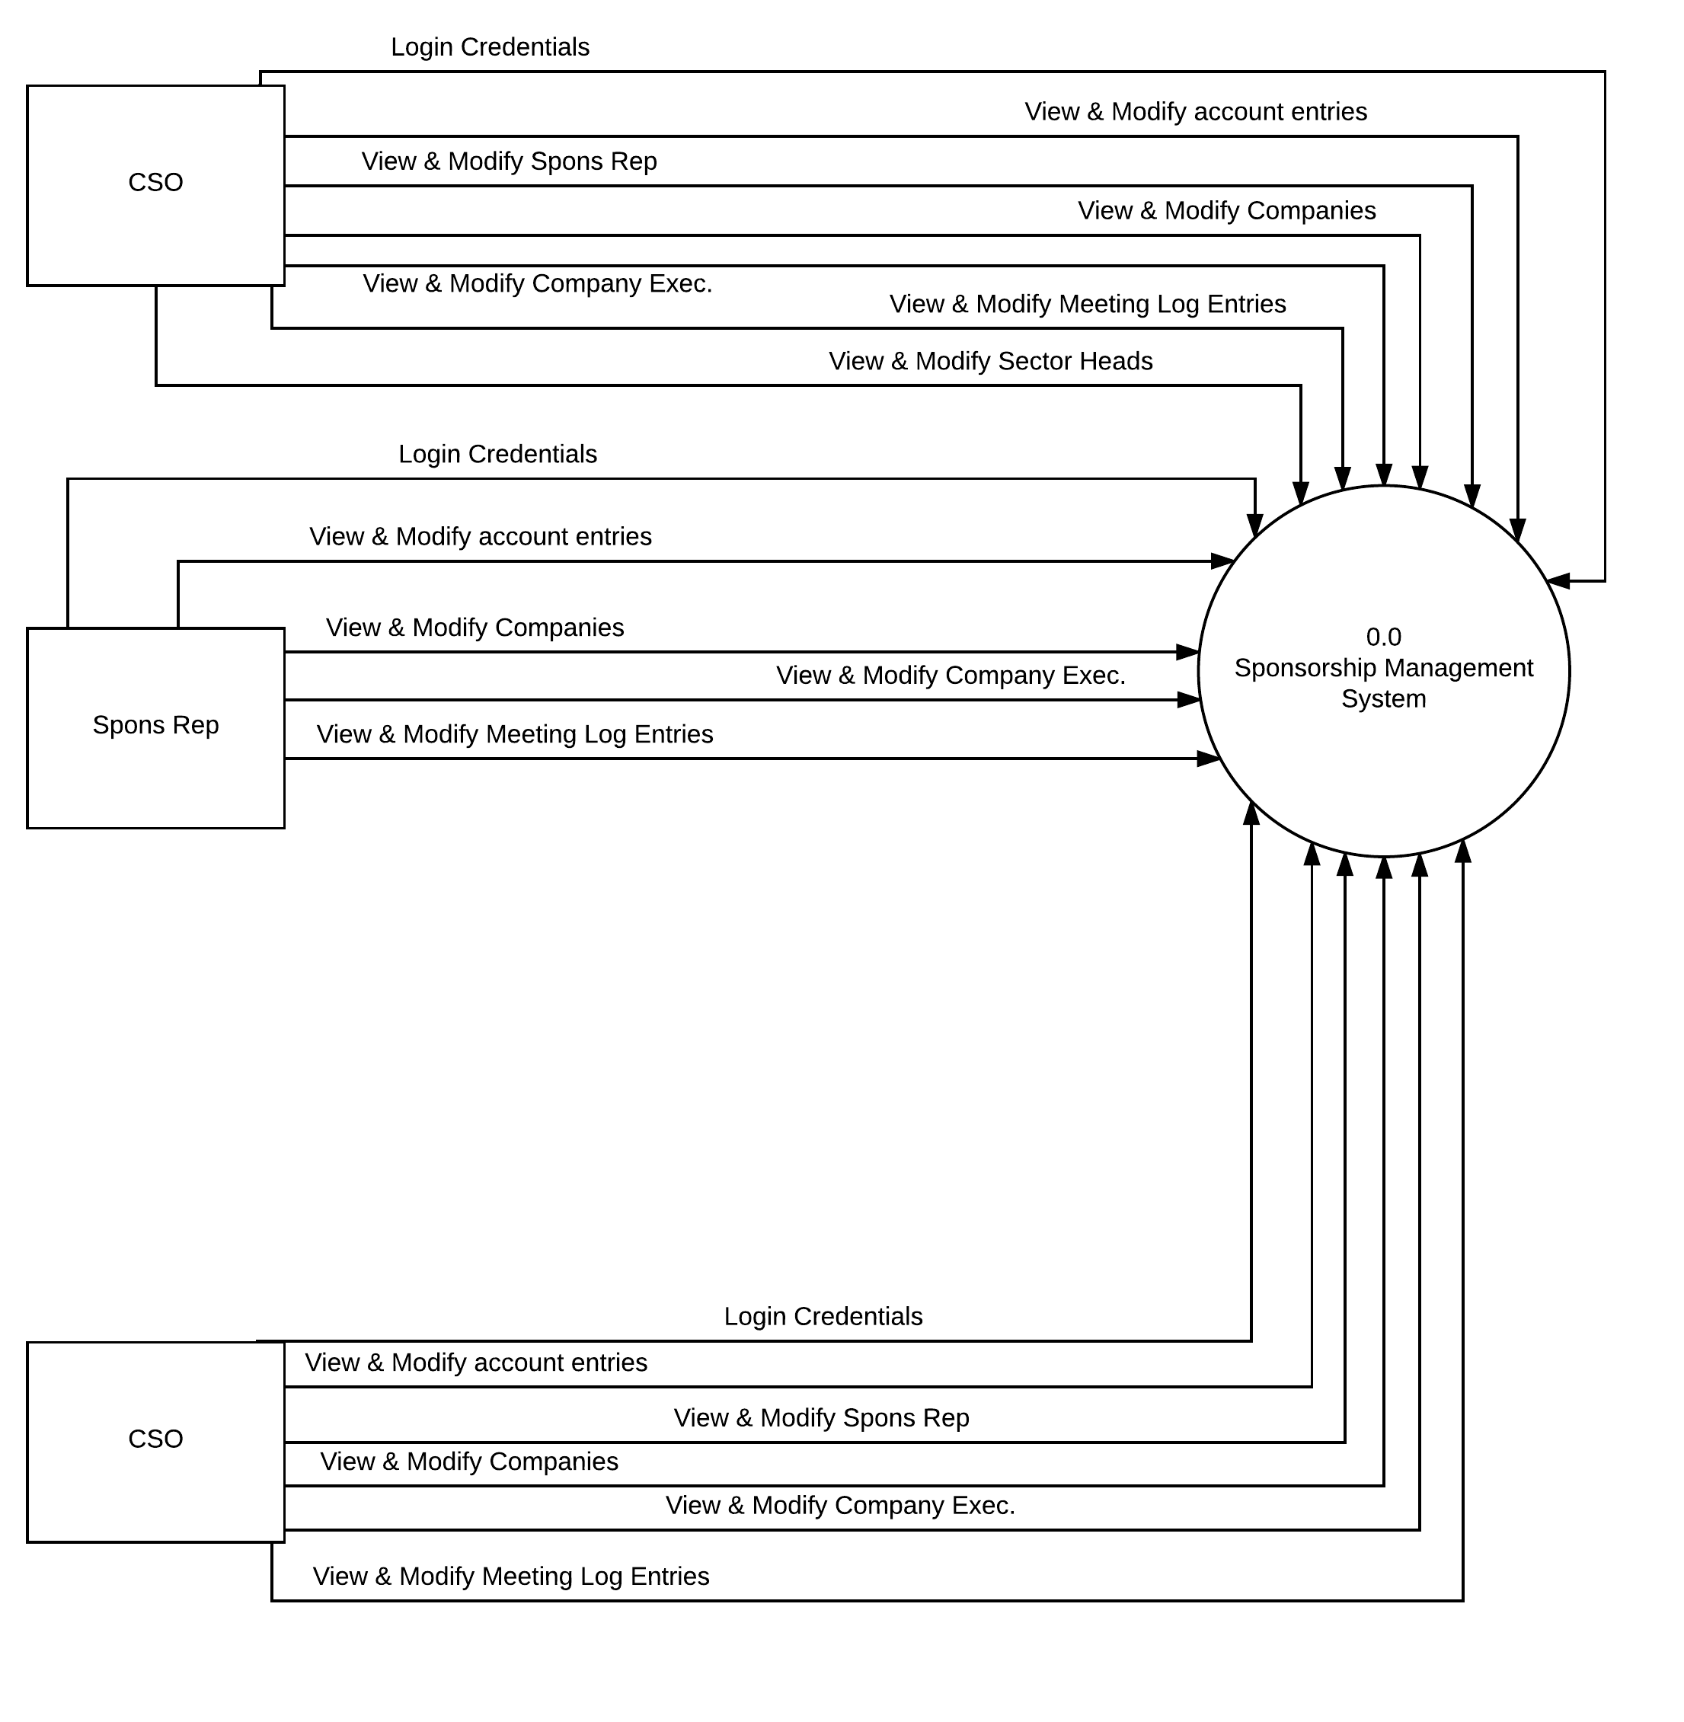

Level 1
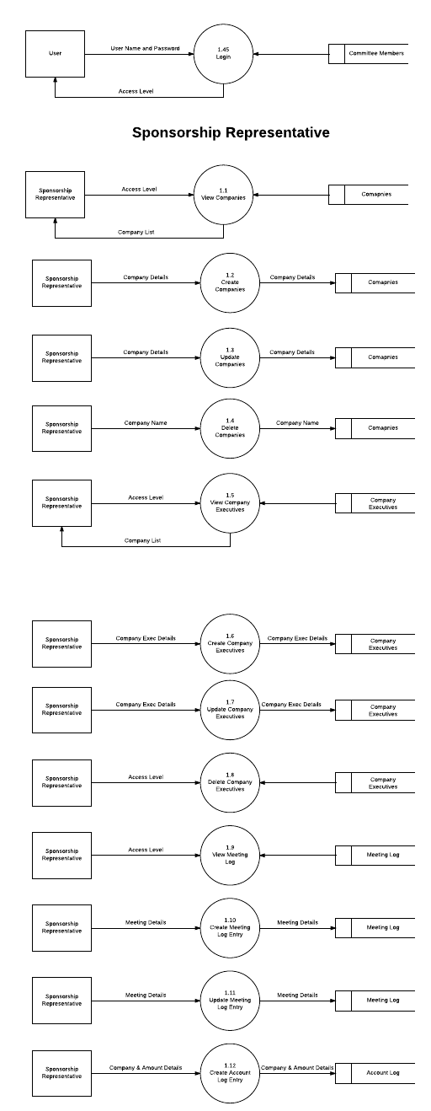
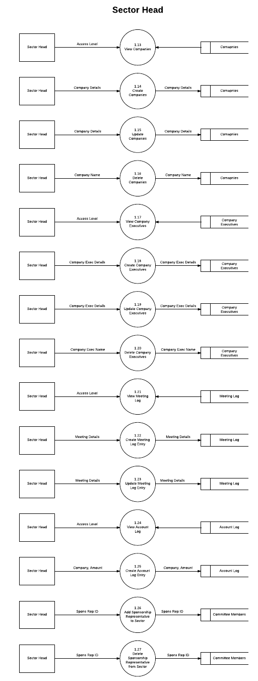
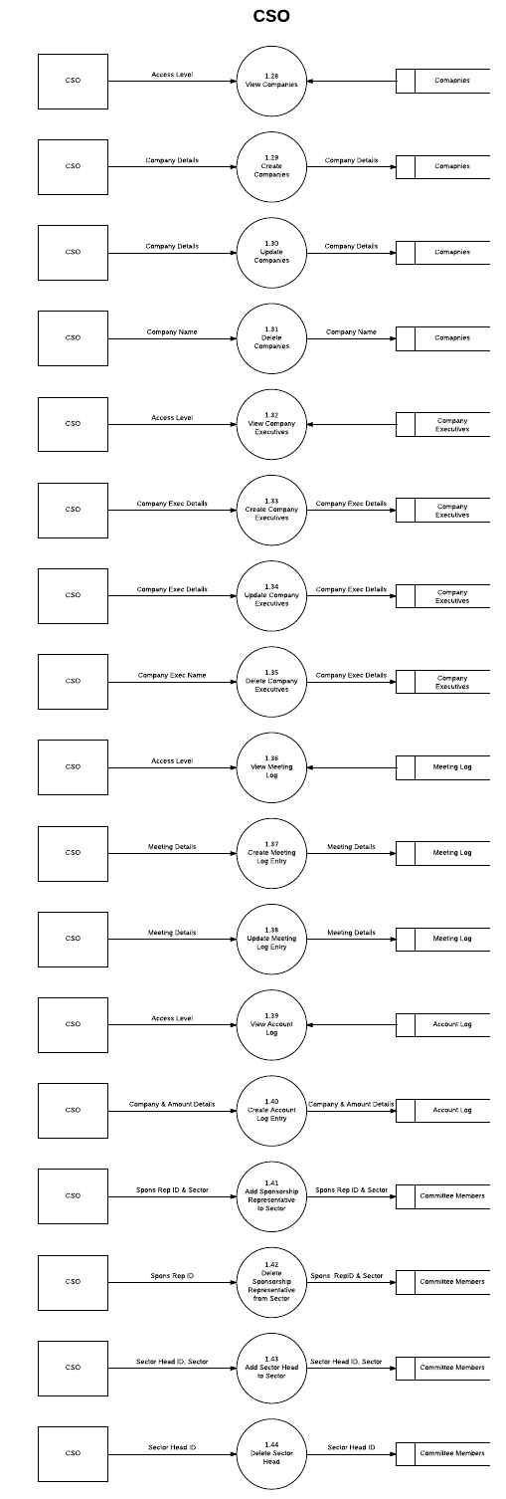
Level 2
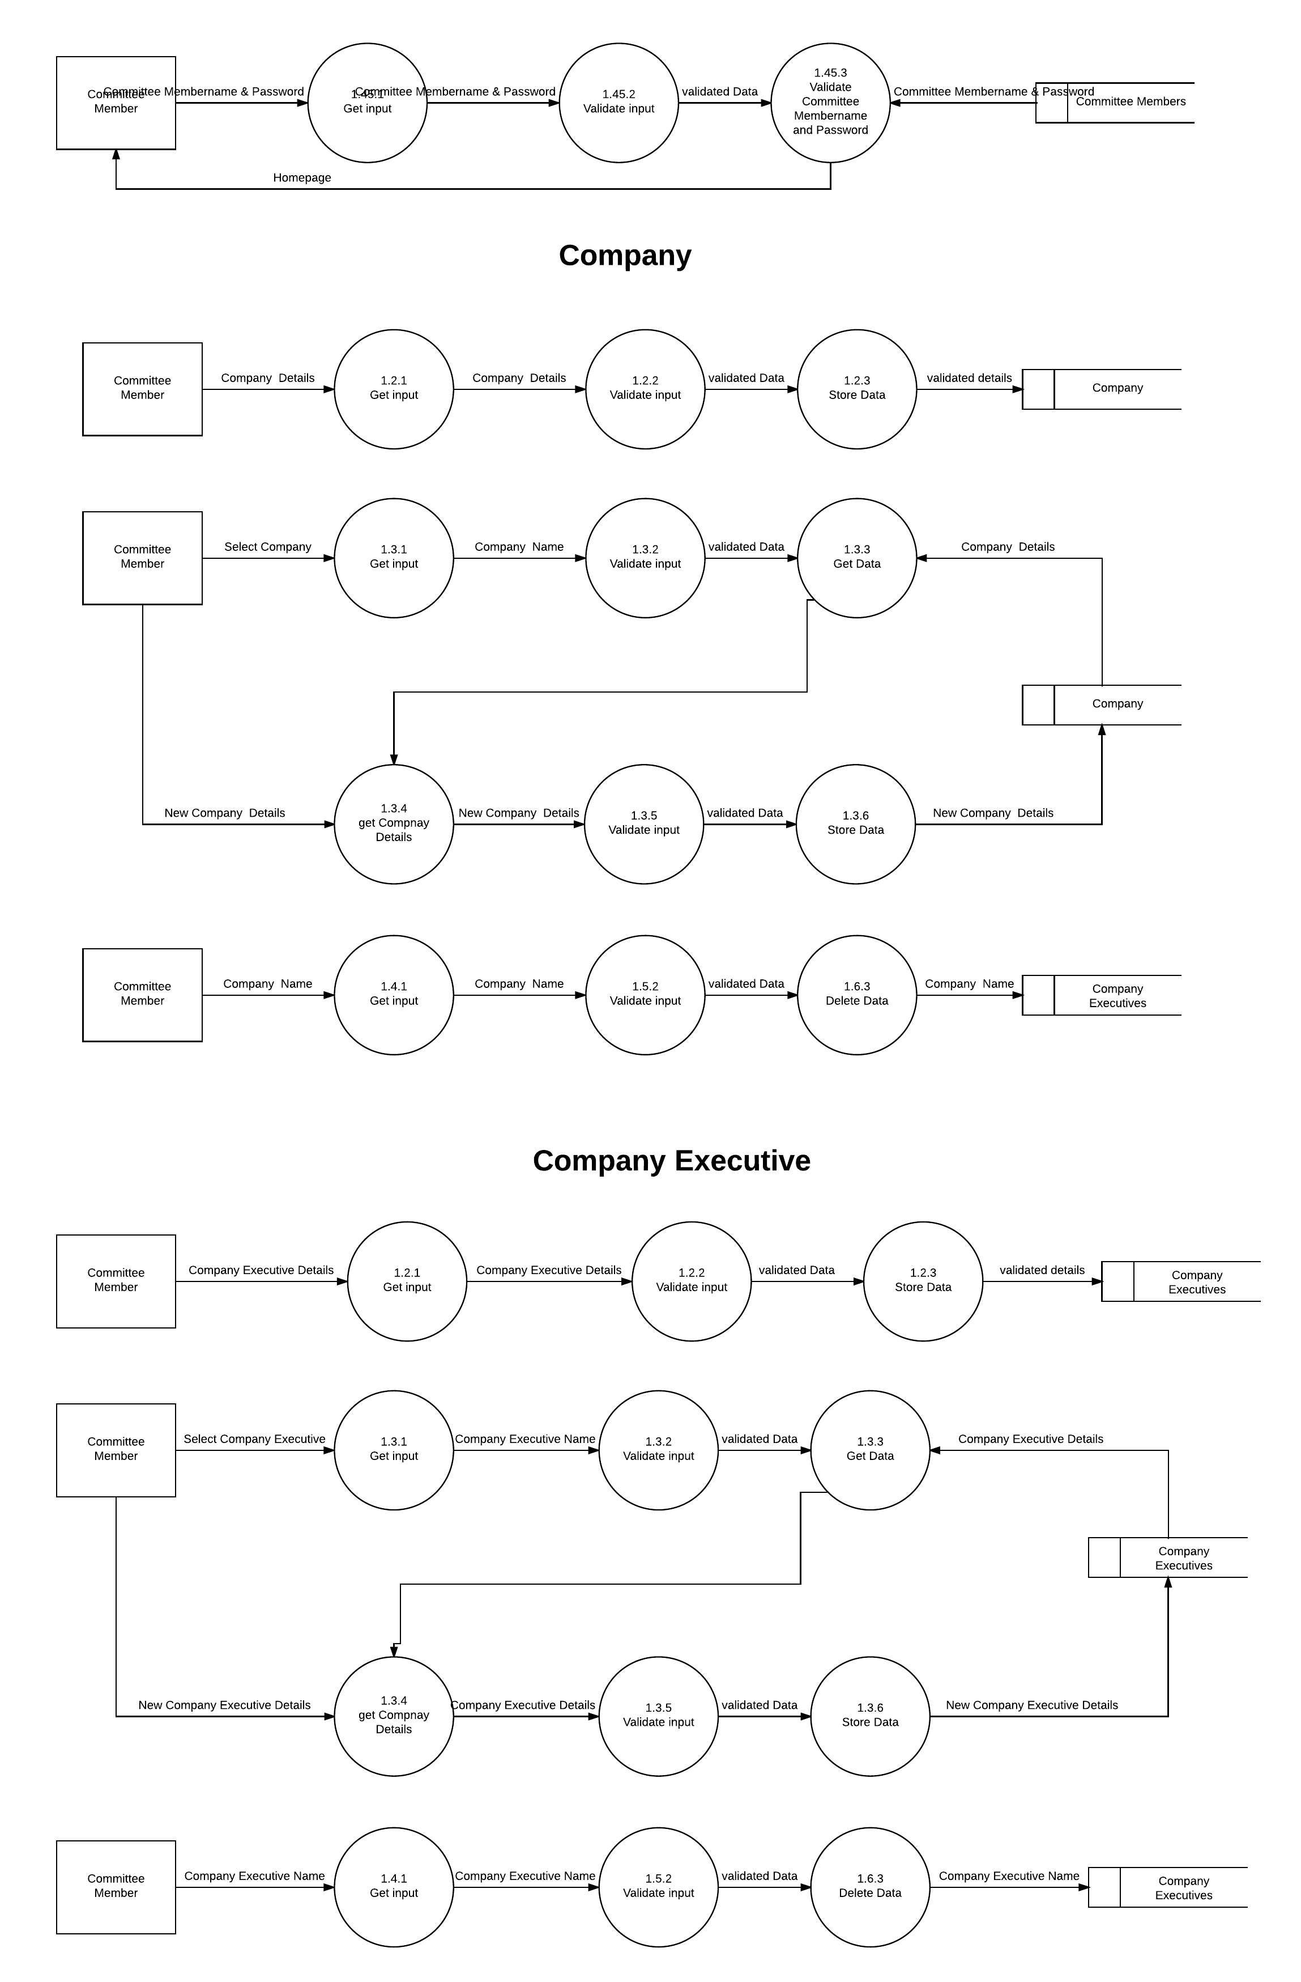
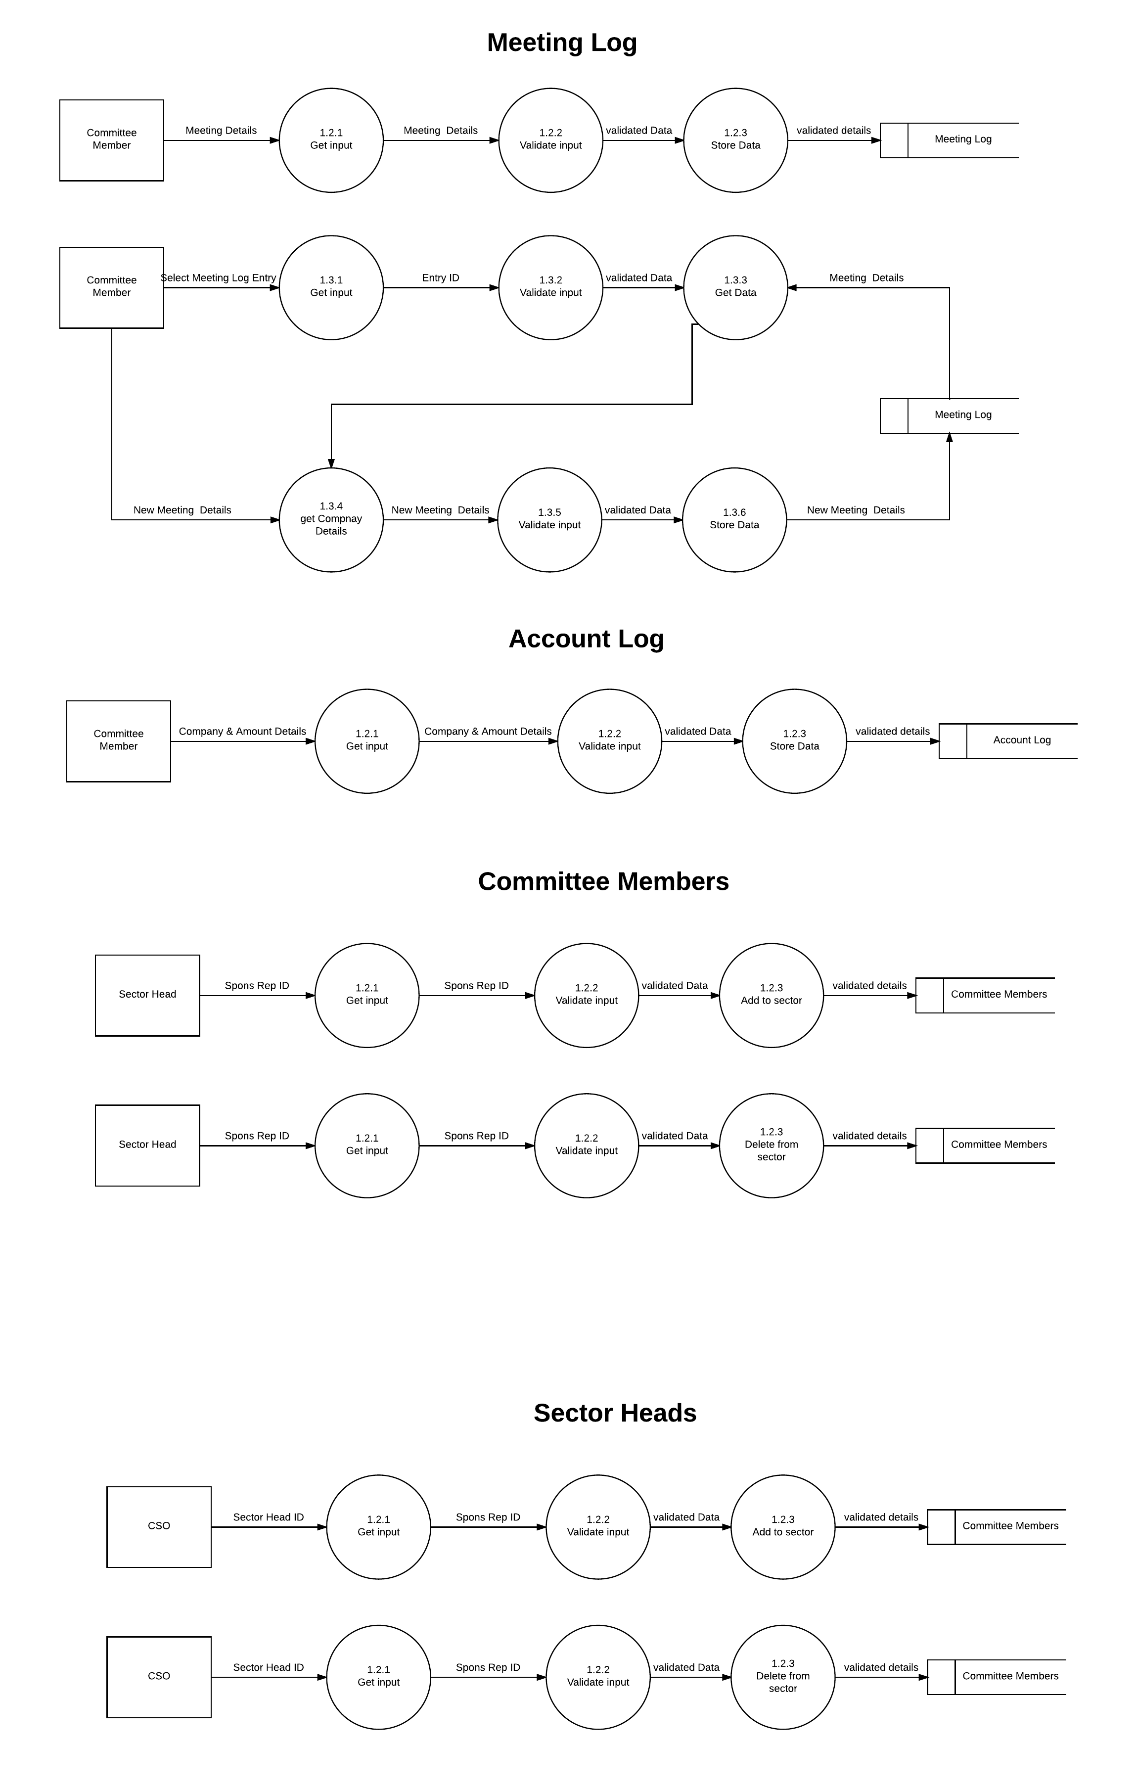
- Network Diagram
: 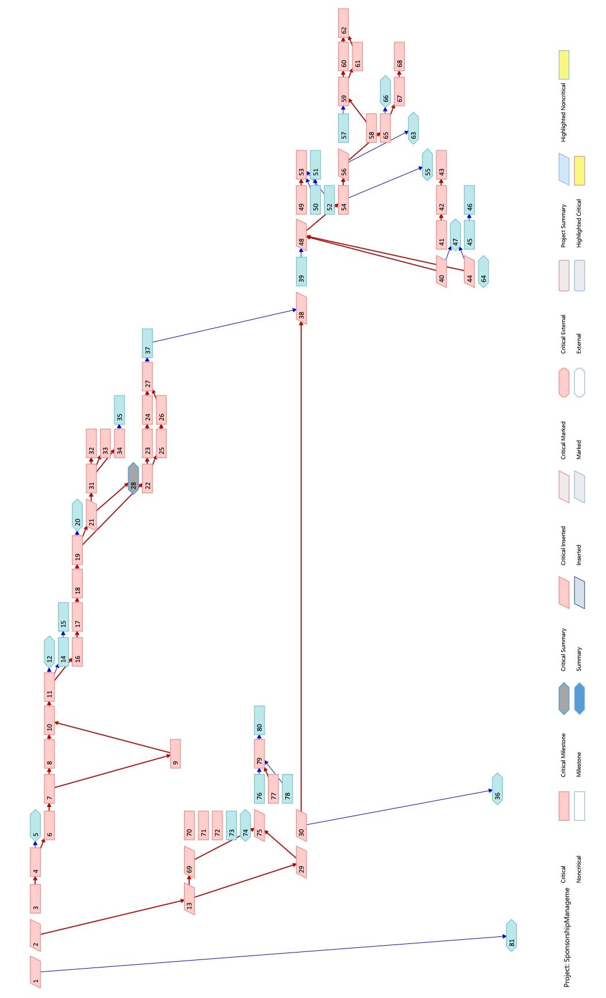
D) Database Design
CREATE TABLE IF NOT EXISTS Event " (
EventID INT(7) UNSIGNED PRIMARY KEY AUTO_INCREMENT,
Organization VARCHAR(50) NOT NULL,
EventName VARCHAR(80) NOT NULL,
StartDate DATE,
EndDate DATE,
UNIQUE KEY(Organization, EventName)
);

CREATE TABLE IF NOT EXISTS Users (
ID INT(9) UNSIGNED PRIMARY KEY,
Organization VARCHAR(50),
EventName VARCHAR(80),
Name VARCHAR(80) NOT NULL,
Department VARCHAR(15) NOT NULL,
Role VARCHAR(40) NOT NULL,
Mobile VARCHAR(15),
Email VARCHAR(50),
Year INT (1),
Branch VARCHAR(25),
foreign key (Organization, EventName) References Event(Organization, EventName)
On Update Cascade
On Delete Cascade
);

CREATE TABLE IF NOT EXISTS AccountLog " (
ID INT(9) UNSIGNED PRIMARY KEY AUTO_INCREMENT,
Organization VARCHAR(50) NOT NULL,
EventName VARCHAR(80) NOT NULL,
Title VARCHAR(100) NOT NULL,
SponsID INT(9) UNSIGNED NOT NULL,
Amount INT(8) UNSIGNED NOT NULL,
TransType ENUM ('Deposit','Withdraw') NOT NULL,
Date DATE,
foreign key (SponsID) References CommitteeMember(ID)
On Update Cascade
On Delete Cascade,
foreign key (Organization, EventName) References Event(Organization, EventName)
On Update Cascade
On Delete Cascade
);

CREATE TABLE IF NOT EXISTS SponsRep (
SponsID INT(9) UNSIGNED PRIMARY KEY,
Sector VARCHAR(15) NOT NULL,
DateAssigned DATE,
Foreign key (SponsID) References CommitteeMember(ID)
On Update Cascade
On Delete Cascade
);

CREATE TABLE IF NOT EXISTS SectorHead (
SponsID INT(9) UNSIGNED PRIMARY KEY,
Sector VARCHAR(15) NOT NULL,
DateAssigned DATE,
foreign key (SponsID) References CommitteeMember(ID)
On Update Cascade
On Delete Cascade
);

CREATE TABLE IF NOT EXISTS SponsLogin (
SponsID INT(9) UNSIGNED PRIMARY KEY NOT NULL,
Password VARCHAR (50) NOT NULL,
AccessLevel ENUM ('SponsRep', 'SectorHead', 'CSO') NOT NULL,
foreign key (SponsID) References CommitteeMember(ID)
On Update Cascade
On Delete Cascade
);

CREATE TABLE IF NOT EXISTS Company (
CMPName VARCHAR(100) PRIMARY KEY,
CMPStatus VARCHAR(15),
Sector VARCHAR(15) NOT NULL,
CMPAddress TEXT

);

CREATE TABLE IF NOT EXISTS CompanyExec (
CEName VARCHAR(50),
CMPName VARCHAR(100),
CEMobile VARCHAR(15),
CEEmail VARCHAR(75),
CEPosition VARCHAR(50),
PRIMARY KEY (CEName, CMPName),
foreign key (CMPName) References Company(CMPName)
On Update Cascade
On Delete Cascade
);

CREATE TABLE IF NOT EXISTS Meeting (
ID INT(7) UNSIGNED AUTO_INCREMENT PRIMARY KEY,
Date DATE,
Time TIME,
SponsID INT(9) UNSIGNED,
Organization VARCHAR(50),
EventName VARCHAR(80),
MeetingType ENUM ('Email', 'Call', 'Meet') NOT NULL,
CEName VARCHAR(50),
CMPName VARCHAR(100),
Outcome TEXT,
Address TEXT,
foreign key (SponsID) References CommitteeMember(ID)
On Update Cascade
On Delete Cascade,
foreign key (CMPName) References Company(CMPName)
On Update Cascade
On Delete Set Null,
foreign key (CEName, CMPName) References CompanyExec(CEName, CMPName)
On Update Cascade
On Delete Set Null,
foreign key (Organization, EventName) References Event(Organization, EventName)
On Update Cascade
On Delete Cascade
);

E) Algorithm Design:

function get_person_name(₹SponsID){
require('DBconnect.php'); //this is needed in every function that uses mySQL
₹rep_name=mysql_query("SELECT Name FROM CommitteeMember WHERE ID = ₹SponsID" );
₹rep_name=mysql_fetch_assoc(₹rep_name);
₹rep_name = ₹rep_name["Name"];
return ₹rep_name;
}

function get_access_level(₹SponsID){
require('DBconnect.php'); //this is needed in every function that uses mySQL
₹rep_access_level=mysql_query("SELECT AccessLevel FROM SponsLogin WHERE SponsID = ₹SponsID" );
₹rep_access_level=mysql_fetch_assoc(₹rep_access_level);
₹rep_access_level = ₹rep_access_level["AccessLevel"];
return ₹rep_access_level;
}

function get_person_sector(₹SponsID){
require('DBconnect.php'); //this is needed in every function that uses mySQL
₹rep_sector=mysql_query("SELECT Sector FROM SponsRep WHERE SponsID = ₹SponsID" );
if(mysql_num_rows(₹rep_sector) == 0)//i.e. you don't find the person with that SponsID in the SponsRep table.
₹rep_sector=mysql_query("SELECT Sector FROM SectorHead WHERE SponsID = ₹SponsID" ); //look in the SectorHead table.

₹rep_sector=mysql_fetch_assoc(₹rep_sector);
₹rep_sector = ₹rep_sector["Sector"];
return ₹rep_sector;
}

function get_earning_report(₹SponsID){
require('DBconnect.php'); //this is needed in every function that uses mySQL
₹rep_name=get_person_name(₹SponsID);
₹rep_amount=0;
₹rep_num_companies=0; //gets nummber of companies signed by that spons rep
₹rep_amount_query = "SELECT Amount FROM AccountLog WHERE SponsID = ₹SponsID";
₹result = mysql_query (₹rep_amount_query );
if(mysql_num_rows(₹result)>0){
while(₹row = mysql_fetch_assoc(₹result)){
₹rep_num_companies++;
₹rep_amount=₹rep_amount + ₹row["Amount"];
}
}
return array(₹rep_name, ₹rep_num_companies, ₹rep_amount);
}

function get_meeting_report(₹SponsID){
require('DBconnect.php'); //this is needed in every function that uses mySQL
₹rep_name=get_person_name(₹SponsID);
₹rep_calls=0;
₹rep_emails=0;
₹rep_meetings=0;
₹rep_meeting_query = "SELECT * FROM Meeting WHERE SponsID = ₹SponsID";
₹result = mysql_query (₹rep_meeting_query );
if(mysql_num_rows(₹result)>0){
while(₹row = mysql_fetch_assoc(₹result)){
switch(₹row["MeetingType"]){
case "Call": ₹rep_calls++;
break;
case "Email": ₹rep_emails++;
break;
case "Meet": ₹rep_meetings++;
break;

}
}
}
return array(₹rep_name, ₹rep_calls, ₹rep_meetings, ₹rep_emails);
}

function get_sector_details(₹SponsSector){
require('DBconnect.php'); //this is needed in every function that uses mySQL
₹num_spons_reps=0;
₹num_sector_heads=0;
₹num_companies_in_sector=0;
₹total_companies_signed=0;
₹total_earned=0;
₹max_earned=0;
₹max_earner_ID=-1;

₹Sector_SR_query="SELECT * FROM SponsRep WHERE Sector = '₹SponsSector'";
₹result=mysql_query(₹Sector_SR_query );

if( mysql_num_rows(₹result)> 0){
while(₹row = mysql_fetch_assoc(₹result)){
₹num_spons_reps++;
₹SponsRepID = ₹row['SponsID'];
₹SponsRepEarningReport = get_earning_report(₹SponsRepID);
₹total_companies_signed=₹total_companies_signed+₹SponsRepEarningReport[1];
₹total_earned=₹total_earned+₹SponsRepEarningReport[2];
if(₹max_earned < ₹SponsRepEarningReport[2]){
₹max_earned = ₹SponsRepEarningReport[2];
₹max_earner_ID = ₹SponsRepID;
}
}
}

₹Sector_SH_query="SELECT * FROM SectorHead WHERE Sector='₹SponsSector'";
₹result=mysql_query(₹Sector_SH_query );
if(mysql_num_rows(₹result)>0){
while(₹row = mysql_fetch_assoc(₹result))
₹num_sector_heads++;
}

₹Sector_CMP_query="SELECT * FROM Company WHERE Sector='₹SponsSector'";
₹result=mysql_query(₹Sector_CMP_query );
if(mysql_num_rows(₹result)>0){
while(₹row = mysql_fetch_assoc(₹result))
₹num_companies_in_sector++;
}

return array("num_spons_reps" => ₹num_spons_reps,
"num_sector_heads"=> ₹num_sector_heads,
"num_companies_in_sector"=> ₹num_companies_in_sector,
"total_companies_signed"=> ₹total_companies_signed,
"total_earned"=> ₹total_earned,
"max_earner_ID"=> ₹max_earner_ID,
"max_earned"=>₹max_earned
);
}

function print_table(₹result){ //array of arritubtes and corresponding sql result we get from querying the attributes
echo '<div align="center">';
echo '<table align="center" style=\"width:100%\" class="output_table">';
echo "<tr>";
₹i=0;
//₹attributes_info = mysql_fetch_field(₹result, ₹i); //gets a lot of data about the attributes...their names, their types etc.
while(₹i < mysql_num_fields(₹result)) {
₹attr=mysql_fetch_field(₹result, ₹i);
echo "<th>".₹attr->name."</th>";
₹i++;
}

while(₹row=mysql_fetch_assoc(₹result)){
echo '<tr>';
foreach (₹row as ₹key => ₹value) {
echo '<td>'.₹value.'</td>';
}
echo "</tr>";
}
echo "</table>";
echo '</div>';
}

function print_sort(₹result){
echo '<form action="sort_search_table.php" class="sort_form" method="post" align="center">';
echo 'Sort by:<select name="order_by">';
₹i=0;

while(₹i < mysql_num_fields(₹result)) {
₹attr=mysql_fetch_field(₹result, ₹i);
echo "<option>".₹attr->name."</option>";
₹i++;
}
echo '</select> ';
echo '<button type="submit" name="submit">Sort</button>';
echo '</form>';
}

function print_search(₹result){
echo '<form action="sort_search_table.php" class="search_form" method="post" align="center">';
echo 'Search by:<select name="search_by">';
₹i=0;

while(₹i < mysql_num_fields(₹result)) {
₹attr=mysql_fetch_field(₹result, ₹i);
echo "<option>".₹attr->name."</option>";
₹i++;
}
echo '</select> ';
echo '<input type="text" name="search_field">';
echo '<button type="submit" name="submit">Search</button>';
echo '</form>';
}

F) Test Cases:

Step Sr. | Step Description | Path & Action | Test Data | Expected Results | Actual Results | Comment
1 | Login | Correct User Name &Password | User name:131080053  Password: advikshetty | Redirects to home page | Redirects to home page | PASS
2 | Wrong Login | Correct User Name & Wrong Password | User name:131080053  Password: ardivekar | Refresh login page and error message | Refresh login page and error message | PASS
3 | Insert Sponsorship Representative | Fill all the fields of the form | Valid SponsID, Name, Password,  Organization, Event, Name  Department, Sector, Email,  Year, Branch | Sponsorship Representative is successfully added | Sponsorship Representative is successfully added | PASS
4 | Insert Sponsorship Representative without all details | Don’t fill all the fields of the form | Valid SponsID, Name, Password,  Organization, Event, Name  Department, Sector, Email, Year  (Branch Missing) | Error message displayed and the Sponsorship Representative is not added | Error message displayed and the Sponsorship Representative is not added | PASS
5 | Update Sponsorship Representative | Fill all the fields of the form | Valid SponsID, Organisation, Event Name, Sector, Password | Sponsorship Representative is successfully updated | Sponsorship Representative is successfully updated | PASS
6 | Insert Company | Fill all the fields of the form | Valid Company Name, Sector, Address | Company is successfully added | Company is successfully added | PASS
7 | Sort by | Choose one field from drop down menu | Selected Sector | Data is sorted by sector | Data is sorted by sector | PAS
8 | Insert Sector Head | Fill all the fields of the form | Valid SponsID, Name, Password,  Organization, Event, Name,  Department, Sector, Email,  Year, Branch | Sector Head is successfully added | Sector Head is successfully added | PASS
9 | Delete Company | Fill all the fields of the form | Valid Company Name, Sector | Company is successfully deleted | Company is successfully deleted | PASS
10 | Search by in Companies Page | Select an option from the drop down and fill the field | Selected sector and Input field=’It’ | Data from having company have ‘It’ as a substring in sector | Data from having company have ‘It’ as a substring in sector | PASS

Conclusion: Hence we have created Use case diagram, Data modelling- ER diagram Functional modelling: Data flow diagram, Database design Algorithm / pseudo code Test cases for our case study.
Experiment No. 6

Aim: To prepare End Project Document
- Milestone report
- Summary of Project Result
- Lesson learned report
- Client Acceptance form

Theory:

Milestone report:
In your Project Plan you will have detailed a number of defined Milestones. These are essentially markers in the sand by which progress can be judged and ensure that if your project is in danger of not delivering, this problem is picked up early enough to ensure it can be dealt with.

Summary of Project result:
In this section you have to include detailed summary of your project result like information about the output

Lesson learned report:
A report that describes the lessons learned in undertaking the project and that includes statistics from the quality control of the project's management products. It is approved by the Project Board, and then held centrally for the benefit of future projects.

Client Acceptance form:
The Client Acceptance form signifies sign-off of the delivered solution, it verifies what deliverables are being turned over to the client and that the client has accepted / approved those deliverables. This form would be completed during the Close phase of a project where the project team is handing over a solution/deliverable to the client.
It includes information regarding project name, project sponsors name, project manager name, name of approver authority etc…

Online Sponsorship Management System

- Milestone Report

Sr No. | Milestone | Date | Status | Responsible
1. | Selected Project and Team | 08/01/2016 | Completed | Abhishek
2. | Project Charter Approval | 15/01/2016 | Completed | Abhishek
3. | WBS Completion | 22/01/2016 | Completed | Abhishek
4. | Estimate Cost | 24/01/2016 | Completed | Abhishek
5. | Create Budget | 25/01/2016 | Completed | Abhishek
6. | Discuss and Finalising of Schedule | 26/01/2016 | Completed | Abhishek
7. | Generation of Estimates | 26/01/2016 | Completed | Abhishek
8. | Design Documents Creation | 01/02/2016 | Completed | Abhishek
9. | Completion of GUI and Login | 09/02/2016 | Completed | Abhishek
10. | Completion of CRUD Queries | 01/03/2016 | Completed | Abhishek
11. | Completion of Querying Features | 13/03/2016 | Completed | Abhishek
12. | Testing Site | 21/03/2016 | Completed | Abhishek
13. | Completion of Monitoring and Control | 26/03/2016 | Completed | Abhishek
14. | Completion of Project | 02/04/2016 | Completion | Abhishek

- Summary of project results

Online sponsorship management project completed successfully. Project team tried to achieve all the objectives. This project has not only achieved the success but also has created good site for attendance management. Team has tried at their level best to develop the project. The results of project are listed here.

  - Committee Members can login and fill their information.
  - Software is needed to maintain database for sponsorship details i.e. to insert, delete, update and search.
  - Committee Members can add and delete the companies’ details.
  - CSO can do the sector allotment.
  - Ease of searching required details from database.
  - Account Log and Meeting Log summary is generated
  - Committee Member can check his meeting details.
  - Progress Overview gets displayed on site.
  - Reduction of paper work due to database.
  - Faster retrieval of information about the companies and their details.
  - Provide user friendly GUI for sponsorship management.

c) Lessons learned report

________________________________________________________________________

Project Name: Sponsorship Management System
Project Sponsor: Manish J.
Project Manager: Abhishek Divekar
Project dates: 4th Feb 2016 - 4th April 2016

1. Did the project meet scope, time and cost goals?
Yes, the project successfully met all the scope, time and cost goals.

2. Reflects on whether or not you met the project success criteria.
We planned to meet all the scope, time and cost goals 5 days before the actual project be delivered. This buffer period gave us an addition cushion to complete the project up to the requirements specified by the sponsor.

3. What are main lessons learned?
- Having good sponsor was instrumental to the project success.
- Team work is essential.
- Good planning paid off in execution.
- Project management software was very useful throughout the project.

________________________________________________________________________

Conclusion: Hence we have created Milestone report Summary of Project Result Lesson learned report for our case study.
Experiment No. 7

Aim: To perform Project Assessment

Theory: Project assessment is needed to check whether our project is successful or not.

Online Sponsorship Management System
Project Assessment
Why do you do this project?
VJTI as any other university has multiple festivals and events happening yearly. One of the most important processes that are critical for a successful festival is securing sponsorship. sponsorship procurement process decided work for my college festival and got placed in the sponsorship department. Soon we realized that there were many redundancies in the process like students used to make new databases of companies to call for sponsorship every year, different students used to contact the same company’s multiple times. we then realized that this was a problem spanning almost every festival. So then we got in touch with the head of sponsorship department and decided to create a web-based application to solve this problem.
All the companies would be saved and updated online thus avoiding the need to create a new database every year. Each sponsorship representative would be able to login to the application and thus be able to view all the companies assigned to him and contact them. Once a student would contact a company nobody else would contact the company. Progress of each meeting could also be stored online so other sponsorship representatives could pick up from where pervious representative left off if he/she is unable to complete the deal. Thus the application, which was developed streamlined the sponsorship sector of festivals.

What did you produce?
We produced a web site to assist in the whole sponsorship procurement process that can be accessed by any one from anywhere. Multiple users can access it simultaneously. There are three levels of access and there are protection features to safeguard against malicious entities. Data is hidden to those without access.
Was the project a success?
Yes, the project was successful because it has passed all testing criteria’s successfully. Now we have to check in reality much it streamlines the sponsorship procurement process.
What went right on the project?
Project has achieved all the objectives. We met all time, scope and budget goals of the project. Finally, it’s a team achievement. Main thing behind the success is good team work.
What went wrong on the project?
Requirements were not well defined at the beginning of the project. We were discovering new project requirements during the process of project completion.

Conclusion: We have done the assessment of online Sponsorship Management System successfully. We got fine results from project assessment.

